Wearable Finger Gesture-Based Smart Controller

MR. Shivang Choudhary
G H raisoni college of Engineering
Nagpur, India- 440016

Shivang.choudhry.aiml@ghrce.raisoni.com

Prof. Ashwani Dange
Assistant Professor,
G H Raisoni College of Engineering,
Nagpur, India- 440016

Abstract-- This paper covers the development of a
The system captures the movement and finger-bending data by using an ESP8266 microcontroller, a flex sensor, and an MPU6050 inertial sensor. Python code is developed on PyCharm, while programming of the ESP8266 microcontroller is done with the use of Arduino IDE. The ESP8266 can be connected to a portable battery bank and works wirelessly; hence, this allows for complete mobility, independent of wired power sources. Data collected will be sent via Wi-Fi to a Python server that carries out some signal processing to enhance its quality before converting it into cursor movement based on the detected bending of the fingers. The prototype proved that this system will respond quickly and accurately to user gestures-even across typical Wi-Fi distances-with very minimal lag. A modified smoothing approach was applied, reducing sensor interference. Basic signal processing techniques have improved the consistency of the signal. The use of commonly available hardware and free software tools keeps the system straightforward, portable, and easy to replicate without needing specialized components. This system has potential applications in smart home systems, medical fields, classroom tools, virtual and augmented reality experiences, and assistive technologies. In summary, this study shows it is possible to create a user-friendly, cost-effective, and efficient interface that combines wireless connectivity, flexible sensing, and a microcontroller with Wi-Fi for effective human-computer interaction.

Keywords: ESP8266, wireless input device, MPU6050, gesture recognition, gesture-based controller, flex sensor, Wi-Fi communication, Human-Computer Interaction (HCI), assistive technology, wearable sensors, augmented reality, virtual reality, microcontrollers with Wi-Fi capabilities, touchless interface, cursor control, open-source hardware, low-cost design, integration of machine learning.

- INTRODUCTION:

Over the past ten years, human-computer interaction (HCI) has rapidly changed, moving away from conventional input devices like keyboards and mice and toward more intuitive and natural-feeling interfaces. Gesture-based control has emerged as a viable substitute for these methods since it enables body movements to be used to communicate with machines rather than direct physical contact. In addition to improving user experience, these interaction techniques expand usability in smart home automation, healthcare, assistive technology, and immersive environments.
Many researchers have looked into using inertial measurement units (IMUs) for gesture recognition. The primary purpose of an MPU6050 is to estimate the movement or orientation of a hand using its onboard gyroscope and accelerometer.
In contrast, an IMU-based solution is lightweight and low-cost; hence, suitable for real-time control. Traditional devices operate well enough in normal daily situations but do not fit into either contactless operations-for instance, sterile medical environments-or users with motor disabilities. Most commercial solutions, including those by Microsoft Kinect and Leap Motion, have a very high cost and poor portability, hence their capability is beyond the reach of small-scale users.
This calls for a practical, low-budget system made from easily available parts. The next sections outline a wireless gesture controller. A portable battery powers the system through an ESP8266 microcontroller along with a single flex sensor. It connects through Wi-Fi to send bending and real-time data to a Python application.
This application uses filtering methods for better stabilization of the signal. Further, the controller acts like a virtual input device, mapping the processed values to cursor movement based on finger bending detected by the flex sensor.

The broad objectives of this study are to:
1. Design a low-cost, lightweight wearable gesture controller utilizing commonly available sensors and microcontrollers.
2. Provide real-time, stable cursor control and reliable gesture recognition by processing flex sensor data.
3. A use case demonstration of how this system can be utilized in such scenarios as accessibility, smart environments, AR/VR, and education.

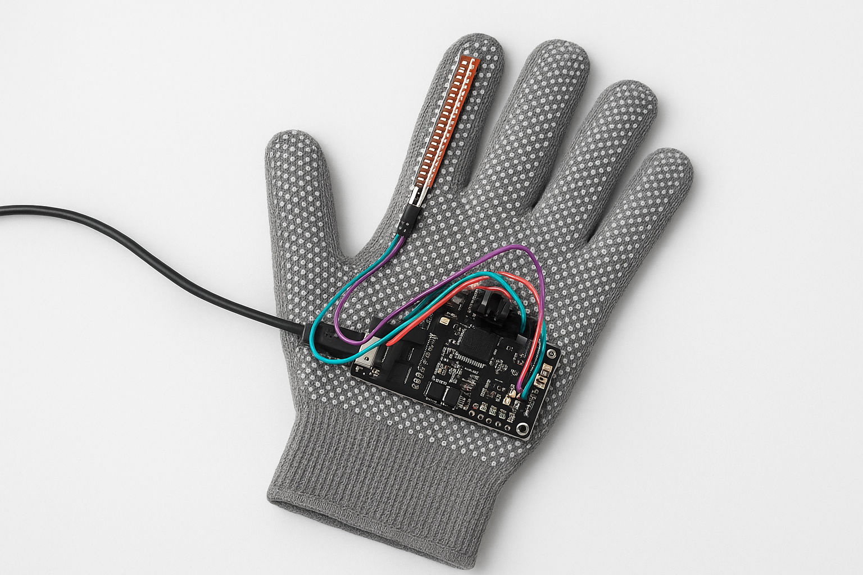
Fig.1. Prototype
This work demonstrates the possibility of developing a portable, easy-to-use gesture-based interface using free and open-source software and low-cost hardware modules. The proposed design connects performance and affordability, furthering developments in accessible and natural human-computer interaction systems.
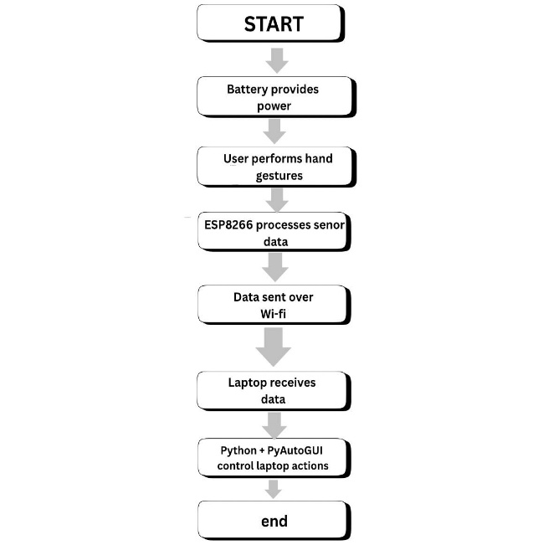

Fig.2. Flowchart

- LITERATURE REVIEW:

This, in fact, has been one of the major areas of research in human-computer interaction: the development of interfaces that are natural to use and that do not involve contact with physical devices. Keyboards and mice are still functional input devices, but they do have physical limitations. On the other hand, gesture-based systems provide an easier and more natural way for people to communicate. Most of the research regarding gesture recognition has focused on IMUs. The most important advantage is the high accuracy at which they can track hand movement. Such IMU-based methods are cheap, light, and more effective in real-time control when compared to camera systems. Other efforts have gone into flexible sensors whose function is the detection of motion of fingers. Wearable technology and flex-sensor gloves turn finger flexion into a digital signal-a very useful functionality in assistive technologies. Such tools enable people with limited mobility to interact in ways they hadn't been able to before.
Wireless technology has made gesture-based systems more practical. Research using microcontrollers with Bluetooth or Wi-Fi, such as the ESP8266 or Arduino, shows that we can create portable, energy-efficient methods for transmitting sensor data. Sensor-based methods are more reliable for everyday use because they don’t need special lighting or a clear line of sight. This is a significant advantage over camera-based systems like Kinect or Leap Motion. In this field, software tools have been important. Prototypes have mimicked keyboard and mouse movements using libraries like PyAutoGUI and other automation frameworks. Many researchers have created less expensive options to costly commercial solutions by combining open-source software with cheap sensors. However, some challenges remain. Stuttering, delays, and missing features are issues with many of the systems in use today. To improve stability, some earlier research has suggested methods like weighted averaging and Kalman filters. These methods usually focus on specific applications like virtual reality, gaming, or physical therapy.
In this work, we bring together multiple components into a wearable system. We use an ESP8266 with Wi-Fi for communication and a single flex sensor that measures how much the finger bends for both left and right click actions. This design focuses on providing a user experience that is affordable, portable, and easy to use while addressing the limitations identified in previous studies.

- METHODOLOGY:

Open source software, wireless communication techniques, and low-cost hardware components came together to build and run the system. The process involved setting up the sensors and hardware, sending and processing data, controlling the cursor, and performing gestures. This all followed a clear plan.

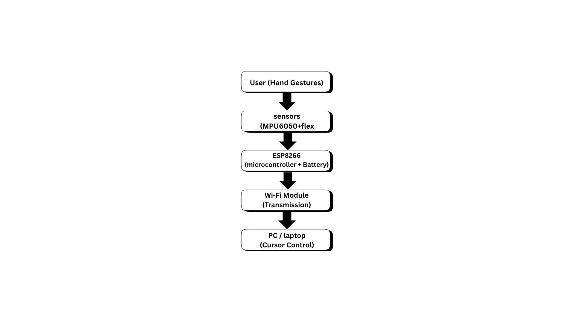 Fig.3. Hardware block diagram

A. Integration of Hardware

The hardware platform comprises two kinds of sensors. One is the MPU6050, a combined accelerometer and gyroscope. It measures and tracks the hand's posture, tilt, and motion in three dimensions. This lets the system understand directional movements that relate to cursor motion.
To control the cursor and perform clicks, a single flex sensor detects finger bending due to its movement-sensing ability. The system translates this bending into actions for the cursor on the screen.
One flex sensor helps identify finger bends. Users can trigger actions like left-click by bending their finger past a specific point.
The ESP8266 microcontroller connects the two sensors. It was chosen for its low power consumption and sufficient analog and digital pins. The flex sensors use the ESP32's analog inputs, while the ESP8266 reads data from the MPU6050 using I²C.
The system is entirely wireless and mobile due to the ESP8266’s battery bank, which acts as a portable and rechargeable power source. Its integrated Wi-Fi, low power consumption, and enough input ports for both sensors made it a fitting choice. The ESP8266 communicates with the flex sensor through its analog inputs. Since the setup runs on a portable battery, the device remains wireless and portable.

B. Framework for Communication

Data packets are sent from the sensor to a Python program on the computer using the ESP8266, which acts as a transmitter. User Datagram Protocol (UDP) handles Wi-Fi communication. UDP was chosen for mouse control applications that require quick responses because it has lower latency than TCP. This makes UDP more reliable and faster when sending continuous small sensor data packets.
Each data packet includes:
1. Accelerometer readings
2. Click detection readings from a single flex sensor
Even with a standard Wi-Fi connection, this simple packet design reduces latency and keeps the process running smoothly.

C. Filtering and Data Processing

The Python server receives and decodes the UDP packets, extracting sensor values. Because of this limitation of the sensor and environment factors, sometimes raw data would be unstable. A weighted smoothing corrects this, and the sliding buffer keeps the latest data point.
Less weight is attached to older values, while every new reading is combined with the previous one. The approach finds a good balance between accuracy and system speed, hence reducing sudden data change while maintaining system responsiveness.
After processing, the data is adjusted to allow control over cursor movement based on the bending of fingers as detected by the flex sensor. The reading of the flex sensor is compared against a set point to determine if a click should be made.

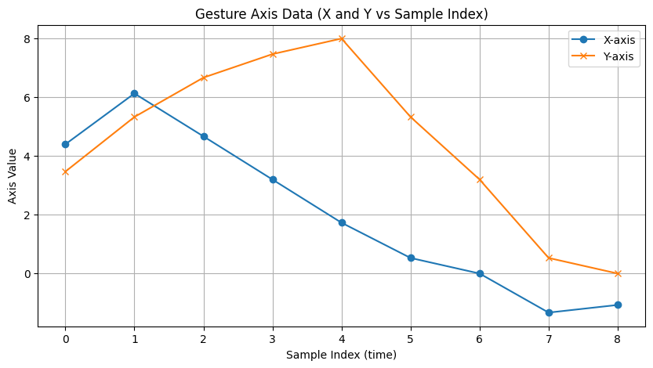

Fig.4. Gesture Axis Data

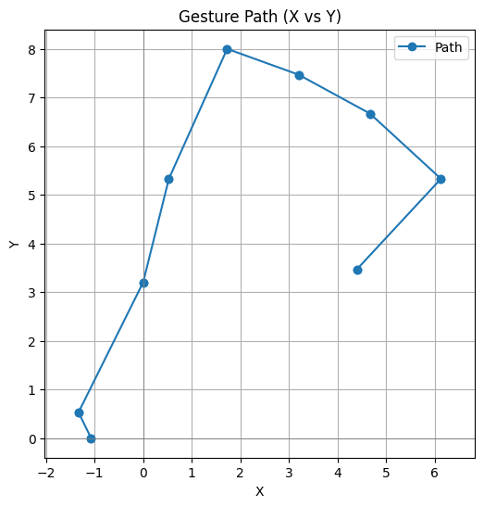
Fig.5. Gesture Path (X vs Y)

D. Mapping Gestures to Actions

Translation of preprocessed data into user actions is the job of the PyAutoGUI library. It does the following with the obtained data:
CURSOR MOVEMENT: The detected tilt coming from the MPU 6050 creates a horizontal and vertical movement of the cursor across the X and Y axes, respectively.
Left Click - A left mouse click is performed when the index finger flex sensor exceeds a set point.
Right Click (Optional): The triggering of the right mouse button can be done using another flex sensor if needed.
This is a design intended to make the system very flexible and highly extensible; this should be able to handle all sorts of different types of gestures or sensors with only minor modifications.

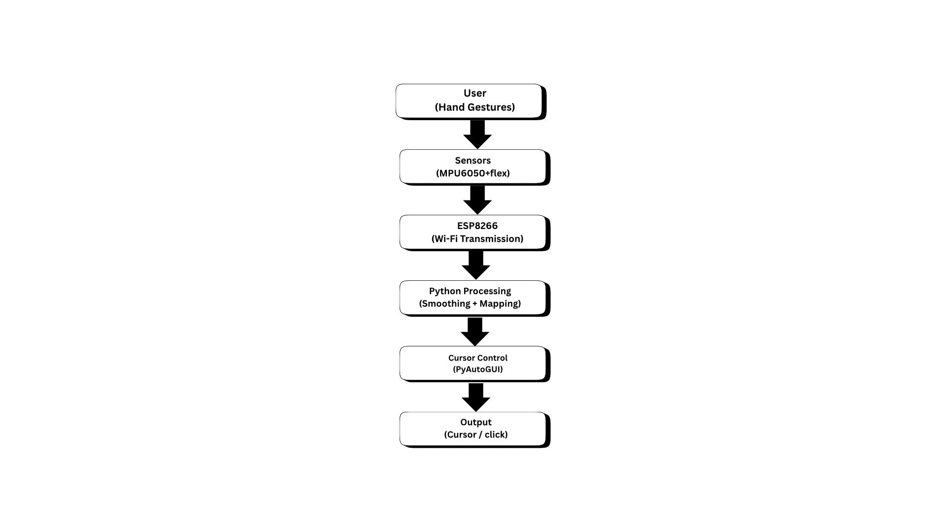

Fig.6. Data Flow Diagram

E. Workflow for Software

The following is a summary of the workflow of the system:
1. Initialization: The ESP8266 sets up analog inputs for flex sensors and begins the I²C communication with the MPU6050.
2. Data Acquisition: The system records real-time data of motions and bending.
3. Wireless Transmission: After packaging, sensor data is sent to the PC over Wi-Fi.
4. Reception and Processing of Data: The Python server receives scaled and smoothed data.
5. Execute the Action: PyAutoGUI maps the processed values to click and cursor movements.
6.Continuous Loop: The process repeats in order to maintain real-time interaction.
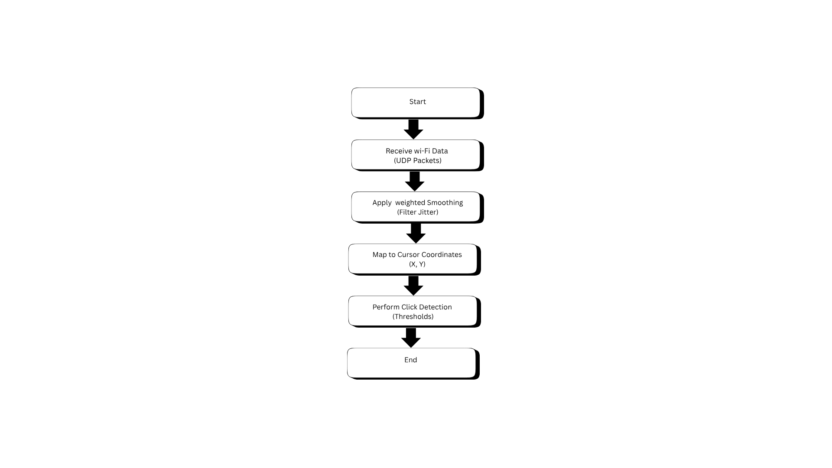
Fig.7. Software Workflow

F. Benefits of the System

We preferred our proposed approach to ensure that the system is affordable, repeatable, and easy to use. Hardware is kept cheap with common sensors like an MPU6050 and a flex sensor combined with an ESP8266. Wi-Fi communication allows for more flexibility than systems based on cables, and this development is easier thanks to Python libraries.
The Python side includes real-time processing of signals and mapping of gestures creation and execution of the application is performed via PyCharm. Programming on the ESP8266 is done using the Arduino IDE, through which communication with sensors is enabled.

- CONCLUSION:

The purpose of the following paper is to describe the design and testing of a wireless controller based on hand gestures. This controller includes a microcontroller ESP8266 powered with a portable battery, one MPU6050 inertial measurement unit, and a flex sensor that detects the bend of a finger. It connects to Wi-Fi and sends data about finger movements to a Python application running on the server. After smoothing, this gets translated into an action-such as a click or cursor movement-in real time. The following example will show how the use of open-source tools and widely available low-cost sensors can result in an interface which can be easily used with any computer.
It has been tested over even standard Wi-Fi and can work great, with accurate clicks and smooth movements along with very minimal lag. The special smoothing feature makes it easier to use, with less jitter compared to raw sensor data. It's easy to build or modify.
It does not require any specific hardware or equipment; it is lightweight software running on normal hardware, hence serving as a good and affordable option when compared to other more expensive commercial devices like Kinect or Leap Motion.
A lot of uses can be made of the controller: in a medical field, it keeps things clean as doctors and other members operating equipment are not required to touch it. This is great for those people who have very limited hand movement, thus they can interact with technology in an efficient way. This can also serve as a tool in giving presentations either at offices or classrooms without physically touching. It enables users, working in VR and gaming, to execute actions naturally with their hand motions. The devices and smart homes it can work with manage the environment, controlling gadgets with just your hands.

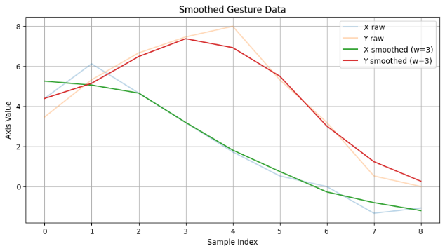

Fig.8. Smoothed Gesture Data

This prototype will implement the left mouse click and some basic pointer movements, but development could go further by including scrolling, zooming, and dragging, or even more complex multi-finger gestures. Generally speaking, due to the inclusion of machine learning, it is possible to recognize a growing variety of gesture types, hence extending flexibility and efficiency in how such systems can be interacted with. It will be even more portable and efficient with some work on power consumption and probably other options for wireless connectivity like BLE or Zigbee.

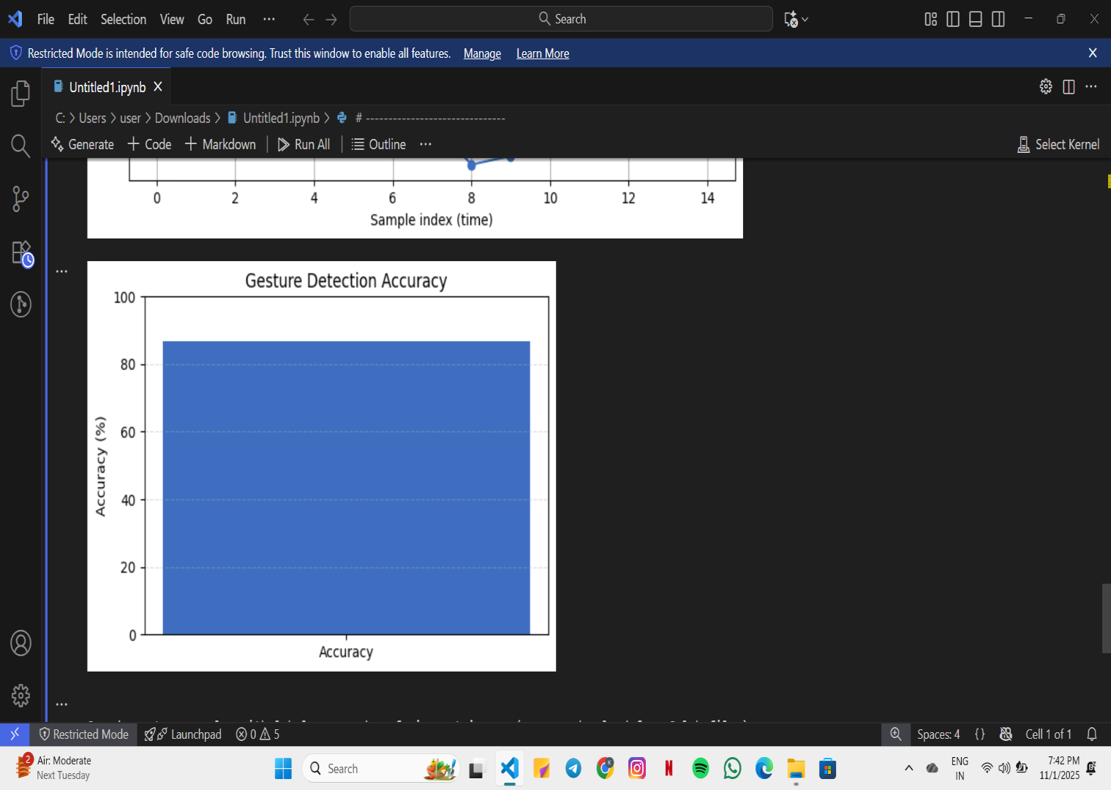

Fig. 9. Gesture Detection Accuracy

It concludes with a single flex sensor, a battery, and
Such kinds of WiFi-capable microcontrollers could be employed for the realization of some practical, real-time, and low-cost gesture-controlled system. The project depicts a more available and natural way to enable people to interact with computers at relatively low hardware and software costs. It would also form the basis for further advances in wireless gesture-controlled technologies.

V. REFERENCES:

1. (SHWASI) Smart Hand Wearable Speech-Impaired Aid: Flex Sensor-based Finger Spelling for Sign Language Communication
Mithun E, Dharun Kumar S, Abirami A; Mathiarasun R J, Harikumar M E are the authors.
Date of Publication: April 21, 2025
2. "Exploiting domain transformation and deep learning for hand gesture recognition using a low-cost dataglove," Sensors, vol. 22, no. 24, pp. 9743107–9743119, Dec. 2022, by M. A. A. Faisal, F. F. Abir, M. U. Ahmed, and M. A. R. Ahad.
3. "Gesture-controlled mechanism of robot using Arduino," EAI Endorsed Trans. Internet of Things, vol. 8, no. 31, pp. 1–8, May 2022, M. A. Haque, S. N. K. Sarker, and A. S. R. Arefin

4. "Hand Gesture Recognition using Flex Sensor and Machine Learning Algorithms," by A. K. Panda, R. Chakravarty, and S. Moulik, in 2020 IEEE-EMBS Conference on Biomedical Engineering and Sciences (IECBES), Langkawi, Malaysia, 2021, pp. 449–453. The doi is 10.1109/IECBES48179.2021.9398789.
5. "A Sensor-Based Hand Gesture Recognition System for Japanese Sign Language," by X. Chu, J. Liu, and S. Shimamoto, in IEEE 3rd Global Conference on Life Sciences and Technologies (LifeTech), Nara, Japan, March 2021, pp. 311–312. DOI: 10.1109/LifeTech52111.2021.9391981
6. IEEE Access, 2024, "A Novel MEMS and Flex Sensor-Based Hand Gesture Recognition and Regenerating System Using Deep Learning Model" (pre-print author version)

7. "A review of hand gesture recognition systems based on noninvasive wearable sensors," Artificial Intelligence for Industry (Wiley / review article), 2023, R. Tchantchane, V. Vernier, A. K. B. Nkongoa, and A. T. Nguifo.

8. Intelligent Wearable Wristband for Gesture Recognition Using EMG Utilizing a Solar Energy Harvester
Writers: V. Kartsch, S. Benatti, M. Mancini, M. Magno, and L. Benini
Date of Publication: May 4, 2018

9. "Gesture-based mouse control system based on MPU6050 and Kalman filter technique," Int. J. Intelligent Syst. Technol. Appl., vol. 21, no. 1, pp. 56–71, Jan. 2023, N. Prasanth, K. Shrivastava, A. Sharma, A. Basu, R. A. Sinha, and S. P. Raja

10. L. Fan et al., "Smart-Data-Glove-Based Gesture Recognition for Human-Computer Interaction with an ESP32-S3 Edge Module," Sensors, vol. 23, 2023. (Comprises Wi-Fi/edge integration, ESP32, and flex sensors.)

11. G. Singh "An Edge AI Solution for Hand Gesture Recognition," ACM/IEEE Edge AI workshop/proceedings, 2024 — (dataset collection using MPU6050; emphasis on TinyML/edge deployment)

12. M. R. Prayogi, "ESP32 and MPU6050 Sensor-Based Air Mouse Design and Development," J. Adv. Inf. Eng. Appl. (IOInformatic), 2025. (Implementable ESP32 + MPU6050 air-mouse design; Wi-Fi/BLE communications discussed).

13. "Continuous Finger Gesture Recognition Based on Flex Sensors," Sensors, vol. 19, no. 18, Art. no. 3986, Sep. 2019 — foundational flex-sensor methods widely cited by 2022–2024 works (useful background and methodology)

14. "Comparing feature usage in IMU-based gesture control for an omnidirectional robot via wearable
glove," (conference paper / ResearchGate), Nov. 2024 — useful for IMU feature selection and fusion strategies.

15. R. K. Jha, A. Singh, and P. S. Rana, “Design and implementation of an accelerometer based wireless hand gesture controlled robot,” in Proc. IEEE Int. Conf. Power, Communication and Information Technology (ICPCIT), Bhubaneswar, India, Oct. 2015, pp. 555–559.

16. S. Wang, Y. Wang, J. Wang, Z. Wang, and L. Zhang, “A wearable smart glove and its application of pose and gesture detection to sign language classification,” in Proc. IEEE Int. Conf. Advanced Robotics and Mechatronics (ICARM), Guilin, China, July 2022, pp. 887–892.

